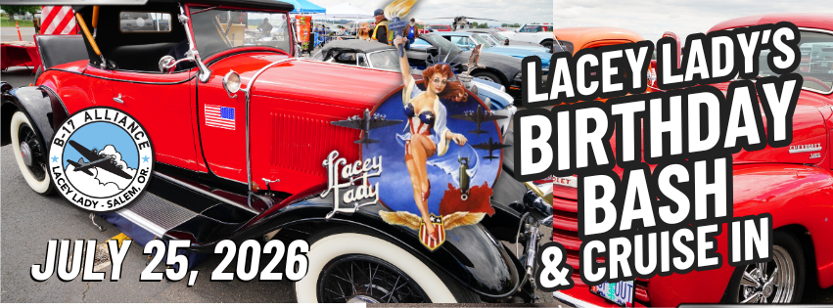
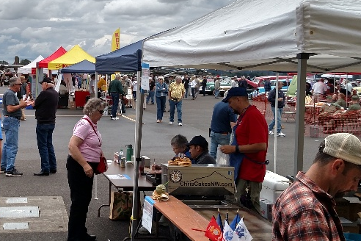
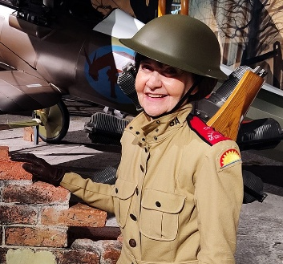
PARTICIPANT/EXHIBITOR AGREEMENT

July 25, 2026, Lacey Lady’s Birthday BASH family festival and Cruise-In.

Entrepreneurs, living historians, aircraft, and classic vehicles are invited to share, sell, and inspire our community at this family festival event celebrating the Lacey Lady’s 79th Birthday.
Help us get the word out! We’ve kept the admission very low to help generate a crowd.
General admission is $5. Per person, $25. Per car, and $25 a family.
Tell your friends, and together we will get the Lacey Lady returned to flight.

Please reserve your space by July 1. This event is being promoted across multiple media platforms. It is a fundraiser to support the restoration of the WWII B-17G Lacey Lady. It is a family event designed to educate and inspire our community.

Each 10’x10’ Vendor/Exhibitor space is $75. The Vendor/Exhibitor is responsible for providing their own tent, tables, and chairs. Tents must be weighted for 60 mph winds. Vendors must list B-17 Alliance as an additional insured. B-17 Alliance is a 501(c)(3) nonprofit and reserves the right to limit vendor registration.

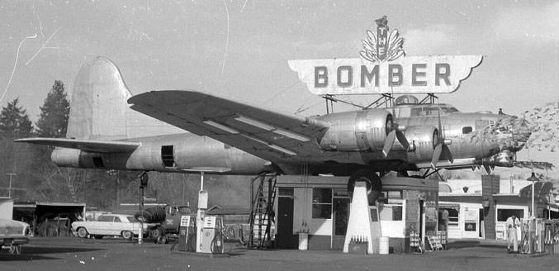
B-17 Alliance is restoring one of America’s most remarkable WWII aircraft, the former iconic “Bomber Gas Station” landmark from Milwaukie, Oregon. The B-17G Flying Fortress won the European Theater during WWII and united our nation. This organization will never forget the sacrifice of a nation on an international and multicultural scale.

With strong community support, the “Lacey Lady will fly again!

Please submit the following form to reserve a spot at this festive family event.

Participation Form for “Honoring the American Spirit of our Military.”

July 25th, 2026, Saturday, 10:00 am to 4:00 pm
Location: The B-17 Alliance Museum & Restoration Hangar 3278 25th St. SE, Salem, OR 97302

Set up is Saturday Morning. Gates open for vendors at 8:30 am. Setup must be completed by 9:45 am. Gates open to the public at 10:00 am. The B-17 volunteer Crew will guide you to your display spot on-site. Please stay for the entire event from 10:00 am to 4:00 pm. Please have extra vehicles removed from the event area by 10:00 am. Parking is behind the B-17 Museum; please abide by the signs and volunteer directions.
2 admission tickets will be allowed per paying vendor. Additional guests are asked to pay the standard admission fee at the gate. Donations are appreciated.

______ I would like to reserve (#) ___ 10’x10’ spaces @ $75. Per space. =________ is enclosed.
______ I will provide a family-related activity (not required)
______ I understand that this event is fundraiser to return the Lacey Lady a WWII B-17G Flying Fortress to her original flying glory.
______ Please contact me about being a Sponsor and receiving ongoing recognition.

REQUIRED: Please check and sign that you have read this and understand
_____ My merchandise or food set up will be wind & rain resistant.
_____ Event Insurance naming B-17 Alliance Foundation additionally insured is attached.
_____ I UNDERSTAND that the only thing that B-17 Alliance is providing is space. All other supplies are my responsibility.
_________________________________ __________________________________
(Signature) (Printed name)

All donations are tax-deductible.
B-17 Alliance is a 501 C3 non-profit corporation. ID # 20-3507294

Please complete your contact information to be considered as a Vendor/Exhibitor.
Corporate Name: __________________________________________________________________
Contact Name: ______________________________________ Email: __________________________________
Address: ______________________________________ City: __________________________ Zip: __________
Phone #: _____________________________________ Cell Phone #: _____________________________
Business Website: __________________________________________________________
Facebook Page: ____________________________________________________________

Make Donations or send registration to:
B-17 Alliance Museum & Restoration Hangar 3278 25th St. SE, Salem, OR. 97302
Email: TerryS@B17Alliance.com For additional information, call: 971-803-2428

Please note that TSA, a government security agency, now regulates Salem Airport. B-17 Alliance has strict orders on egress and ingress. Participants must follow our volunteers' instructions when coming and going from our site. Thank you for helping us cope with regulations.

